**Lease Management**

## Project Overview

This project, Salesforce Lease Management System, is designed to address the common challenges faced in property and lease management, such as inefficient data handling, delayed tenant communication, and inconsistent record-keeping. The primary objective of this project is to centralize all lease-related data within Salesforce and automate critical processes, thus improving the overall efficiency of property management operations.

The goal is to deliver a comprehensive solution by leveraging Salesforce’s cloud-based CRM capabilities, along with custom objects, automated workflows, and data validation features. Through the use of these Salesforce tools and functionalities, this project aims to create an integrated lease management platform that minimizes manual work, ensures data accuracy, and fosters timely, consistent communication with tenants.

With this project, we aim to enhance operational efficiency, improve the tenant experience, and increase data accuracy by consolidating all information in a single, accessible system. Additionally, the system will enable easy tracking and management of tenant information, payments, and lease agreements, ultimately supporting the long-term goals of our property management team and the organization.

**Project Goals:**

* **Enhance Efficiency:**

Streamline tenant and property management with custom Salesforce solutions.

* **Improve Communication:**

Automate tenant communications regarding payments, renewals, and notices.

* **Increase Data Accuracy:**

Minimize data entry errors with validation rules and automation.

* **Provide Insights:**

Use dashboards and reports for a comprehensive view of lease management metrics.

# Objectives

The Salesforce Lease Management System project has clearly defined objectives aimed at addressing business goals and achieving specific outcomes to enhance property management efficiency, data accuracy, and tenant communication.

**Business Goals:**

1. **Improve Operational Efficiency:**

One of the primary business goals is to streamline property management operations by centralizing data and automating processes within Salesforce. This includes reducing manual tasks, such as tenant data entry and payment tracking, allowing property managers to focus on higher-value activities.

1. **Enhance Tenant Satisfaction**:

By implementing timely, automated communication with tenants, the project aims to improve tenant relationships and reduce late payments. Notifications regarding payment deadlines, lease renewals, and other important updates will keep tenants informed, fostering trust and satisfaction.

1. **Ensure Data Security and Accuracy**:

Given the importance of accurate records in property management, the project aims to maintain secure, error-free data by using Salesforce’s validation rules and business logic. Reliable data enhances decision-making and supports compliance with organizational policies.

1. **Scalable Solution for Future Growth:**

As property portfolios grow, the system should be able to accommodate an expanding number of properties and tenants without compromising performance or ease of use. The project aims to create a scalable solution that supports long-term growth and evolving business needs.

**Specific Outcomes:**

1. **Comprehensive Lease Management Dashboard:**

The project will deliver a customizable dashboard that provides a quick overview of essential metrics, such as occupancy rates, upcoming renewals, and outstanding payments. This will give property managers valuable insights at a glance, aiding in better decision-making.

1. **Custom Objects for Tenants, Properties, and Payments**:

Custom Salesforce objects for Tenant, Property, and Payment will be designed to ensure a structured, centralized repository for all relevant data. These objects will enable property managers to track tenant information, link tenants to properties, and monitor payment history seamlessly.

1. **Automated Communication Templates:**

Email templates will be created to streamline tenant communications, including payment reminders, overdue notices, and lease renewal notifications. These templates will incorporate Salesforce’s merge fields to personalize communications, enhancing professionalism and tenant engagement.

1. **Validation Triggers for Data Accuracy:**

Apex triggers will be implemented to ensure data accuracy. For example, the system will include a custom trigger to prevent tenants from being assigned to multiple properties, reducing errors and ensuring data integrity.

1. **Reports and Analytics:**

The project will include a set of custom reports, allowing property managers to analyze trends in lease expirations, payments, and occupancy rates. This will support data-driven decision-making and enable property managers to address issues proactively.

1. **User Training and Documentation:**

To ensure a smooth transition to the new system, user training materials and detailed documentation will be provided. This will include step-by-step guides, video tutorials, and reference materials to empower users to maximize the system’s potential.

# Salesforce Key Features and Concepts Utilized

This project utilizes several key Salesforce features and concepts that are critical to creating a robust lease management system. Here is a summary of the main components implemented.

**Custom Objects**

* **Tenant Object:**

Stores information about tenants, such as name, contact information, lease duration, and associated property.

* **Property Object:**

Holds data on properties, including property location, type, rental value, and availability.

* **Payment Object:**

Tracks payments made by tenants, including amount, payment date, and status.

**Apex Trigger**

* **Prevent Duplicate Assignments:**

The trigger ensures each tenant can only be assigned to one property at a time, enhancing data accuracy and consistency.

**Apex Classes**

* **Validation Logic:**

An Apex class named testHandler enforces business rules, preventing data entry errors by validating tenant and property assignments.

**Email Templates**

* **Automated Communication:**

Email templates allow automated reminders for payment dues and lease renewals, enhancing tenant engagement and communication consistency.

**Reports and Dashboards**

* **Comprehensive Insights:**

Custom reports and dashboards provide property managers with visual insights into tenant payments, lease expirations, and other KPIs critical to business operations.

# Detailed Steps to Solution Design

This section outlines the detailed steps taken to design a solution that meets the project requirements.

* 1. **Data Model Design**

**Tenant and Property Relationship:**

Tenant records are associated with properties through a lookup relationship. This ensures that each tenant is correctly linked to a single property.

* **Tenant Object Fields:** Name, Contact Info, Lease Start Date, Lease End Date, Assigned Property.
* **Property Object Fields:** Property ID, Location, Type, Rental Rate, Status (Available/Rented).
* **Payment Object Fields:** Amount, Due Date, Paid Date, Status (Paid/Unpaid), Tenant.

**4.2 Business Logic Implementation**

**Trigger Logic - Prevent Duplicate Assignments**:

**Trigger:**

The custom trigger TenantAssignmentTrigger validates that a tenant is assigned to only one property.

**Example Code:**

public class testHandler {

public static void preventInsert(List<Tenant__c> newlist) {

Set<Id> existingPropertyIds = new Set<Id>();

for (Tenant_c existingTenant : [SELECT Id, Propertyc FROM Tenantc WHERE Property_c != null]) {

existingPropertyIds.add(existingTenant.Property__c);

}

for (Tenant__c newTenant : newlist) {

if (newTenant.Property_c != null && existingPropertyIds.contains(newTenant.Property_c)) {

newTenant.addError('A tenant can have only one property');

}

}

}

}

**4.3 User Interface (UI) Design**

**Page Layouts:**

Custom page layouts for Tenant, Payment, and Property objects.

Layouts allow easy navigation and provide property managers with a quick overview of tenant details, payments, and property assignments.

**Lightning Components:**

Custom components may include specialized forms or data displays for enhanced user experiences.

**4.4 Communication Templates**

**Email Templates:**

Payment reminders and lease renewal notices were implemented using merge fields to populate tenant-specific details dynamically.

**Example Email Content:**

Dear {Tenant__c.Name},

Your payment of {Payment_c.Amount} is due on {Payment_c.Due_Date}.

Please ensure timely payment to avoid late fees.

Regards,

Property Management Team

# Testing and Validation

The testing phase included rigorous unit testing, interface testing, and integration testing to ensure the solution meets business requirements.

**5.1 Unit Testing**

**Apex Classes:**

Test classes were written to validate trigger logic, specifically to prevent multiple assignments of a single property.

**Sample Test Class:**

@isTest

private class testHandlerTest {

@isTest static void testPreventInsert() {

Tenant_c tenant1 = new Tenantc(Name = 'Tenant A', Property_c = '001xx000003DGXlAA');

insert tenant1;

Tenant_c tenant2 = new Tenantc(Name = 'Tenant B', Property_c = '001xx000003DGXlAA');

Test.startTest();

try {

insert tenant2;

} catch (DmlException e) {

System.assert(e.getMessage().contains('A tenant can have only one property'));

}

Test.stopTest();

}

}

**5.2 User Interface Testing**

**Testing Page Layouts and Navigation:**

Ensured that layouts display correctly across all user roles and that all necessary information (tenant name, property status, payment details) is readily accessible.

**Email Template Testing:**

Each email template was tested to confirm that it accurately pulls tenant-specific data and sends correctly.

**5.3 Integration Testing**

**Data Flow Testing:**

Validated seamless data flow between Tenant, Property, and Payment objects, confirming that all records are created, updated, and viewed as expected.

## Key Scenarios Addressed by Salesforce in the Implementation Project

**Tenant-Property Assignment Validation**

One of the most significant challenges in lease management is ensuring that each property is assigned to only one tenant at a time. To address this, the project implements a robust validation logic using Salesforce Apex triggers.

**Key Features of the Validation Logic:**

Custom Trigger Implementation: The preventInsert trigger verifies that a property cannot be assigned to multiple tenants. When a new tenant record is created or updated, the trigger checks whether the Property__c field already exists in the system. If the property is already linked to another tenant, an error message is displayed: "A tenant can have only one property."

Error Prevention: By incorporating this validation, the system eliminates duplicate or conflicting property assignments, ensuring data accuracy and operational efficiency.

Scalability: The validation logic is scalable and accommodates future data growth, handling an increased number of tenants and properties without performance degradation.

This scenario ensures that property managers can confidently track tenant assignments, avoid disputes, and maintain organized records.

**Payment Tracking**

Managing payments effectively is critical for any lease management system. Salesforce enables seamless tracking and monitoring of payments through the Payment__c custom object and associated automation.

**Features of Payment Tracking:**

**1. Overdue Payment Reminders:**

Using Salesforce automation tools like Workflow Rules or Flows, payment reminders are automatically sent to tenants before and after payment due dates. For instance, tenants receive an email five days before their payment is due and again on the due date if payment is not received.

**2. Payment Histories:**

The Payment__c object tracks all transactions, including payment amounts, payment dates, and statuses (e.g., Paid, Overdue, Pending). Property managers can view comprehensive payment histories for each tenant, making it easy to resolve disputes or analyze patterns.

**3. Real-Time Status Updates:**

Payment statuses are updated dynamically through the system, allowing property managers to see the latest payment details instantly.

This scenario ensures that payments are well-organized, overdue cases are minimized, and managers have a clear view of financial performance.

**Automated Communication with Tenants**

Tenant communication is vital for maintaining positive relationships and ensuring smooth operations. Salesforce streamlines communication through automated email templates and workflows.

**Automation Features:**

**1. Email Templates:**

Professionally designed templates are used to send automated messages such as payment reminders, lease renewal notices, and overdue alerts. These templates include merge fields to personalize emails, addressing tenants by name and referencing property details.

**2. Workflow Automation:**

Workflows or Process Builder automates the sending of emails based on specific triggers. For example:

A lease renewal reminder is automatically sent 30 days before the lease end date.

A confirmation email is sent when a payment is received.

**3. Mass Emails for Updates:**

Salesforce’s mass email functionality allows property managers to send announcements, such as maintenance schedules or policy changes, to all tenants at once.

By automating tenant communication, this scenario reduces manual effort, ensures timely updates, and enhances tenant satisfaction.

**Reporting and Dashboards**

Effective decision-making relies on access to accurate and actionable insights. Salesforce’s reporting and dashboard capabilities provide property managers with the tools to analyze data and track performance metrics.

**Key Reports Created:**

**1. Overdue Payments Report:**

This report lists tenants with overdue payments, categorized by the number of days overdue. Managers can filter data by property or tenant and prioritize follow-ups accordingly.

**2. Tenant Status Report:**

Displays active, pending, and past tenants. This report helps managers track tenant occupancy and plan for lease renewals or property vacancies.

**3. Property Assignment Report:**

Provides an overview of all properties, their tenants, and occupancy statuses. It highlights available properties, ensuring efficient resource allocation.

**Dashboards Created:**

**1. Occupancy Dashboard:**

Visualizes the percentage of occupied versus vacant properties, helping managers understand portfolio performance at a glance.

**2. Payment Status Dashboard:**

Shows the total amount collected, overdue payments, and upcoming payments due within the next 30 days.

**3. Renewal Trends Dashboard:**

Tracks upcoming lease expirations and renewal rates, enabling proactive management of tenant retention.

**Output**:

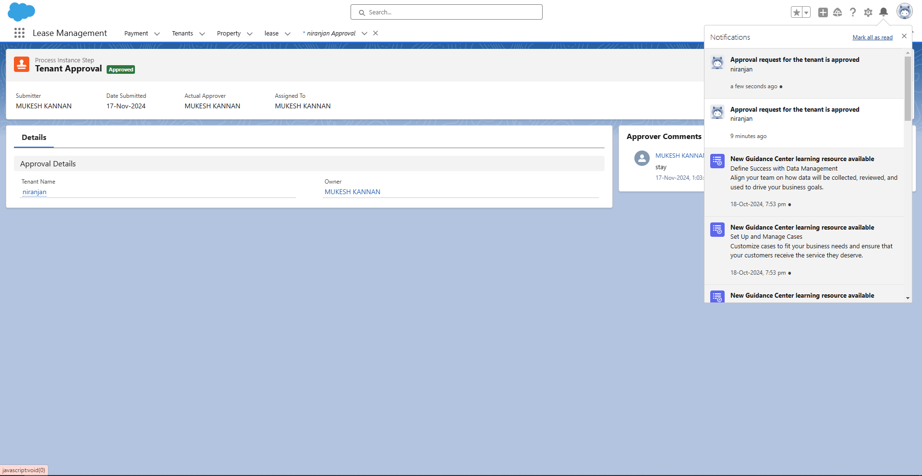

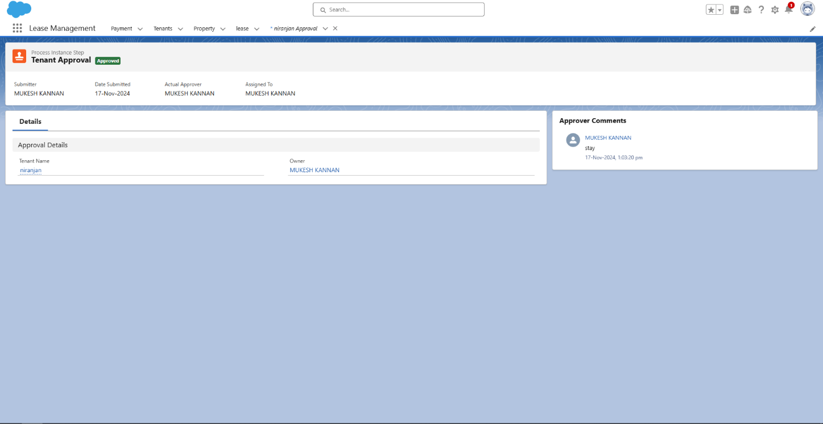

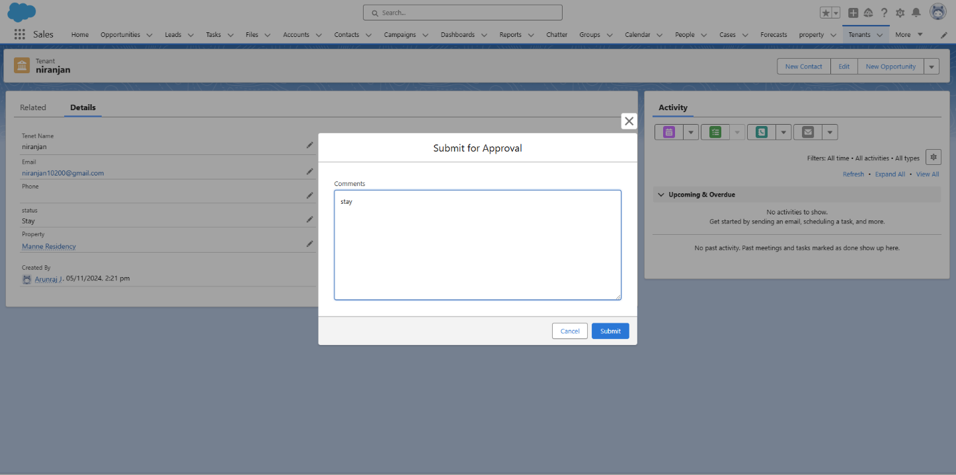

# Conclusion

**Summary of Achievements**

The Salesforce Lease Management project successfully automated tenant-property assignments, payment tracking, and tenant communication. Custom objects and Apex triggers addressed key business requirements while improving data integrity and operational efficiency.

**Lessons Learned**

Through this project, the importance of maintaining robust validation rules, clear data models, and well-designed UI became apparent, all of which contribute to improved user experience and data reliability.

**Future Enhancements**

Potential enhancements could include additional automated workflows, integration with other property management platforms, and expanding reporting capabilities to include more advanced analytics.